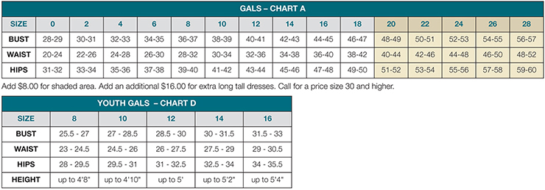

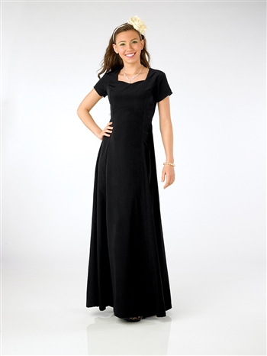 Rhinestone necklace set(optional)
Our Price: $8.00
Dress Price: $60.00
Includes shipping
"Denise" Sweetheart Neckline
Short sleeve sweetheart neckline floor length gown with princess
seams. Classic poly peach skin fabric. Tie backs and back zipper.
Machine washable.
Dresses come with unfinished hem. If you need help hemming your daughter’s dress, please let me know.
Regular length fit 5'11" and below.
.
------------------------------------------------------------------------------------------------------------------------------------------
Dress Order- Please return by March 25th
Student name:______________________________
Dress size:______________________________
Necklace: Yes / No
Total of check or cash included:________________ ($60 for dress only; $68 for dress plus jewelry set)

Make checks payable to Orchestra Adventures. I will send the order in once I have received payment.

