Orchestra Practice Record:
Name______________________________ Date: April 27th – May 15th

What to practice | T | W | Th | F | S | S | M
- Finger Exercises – Candy Squishers
10 times each finger – BOTH hands
- Hammer fingers on instrument WITHOUT your bow. Listen closely to hear the note
On D – E - F# - G play on A – B – C# - D

- String Builder pg. 14
- #62
- Play the Duet with the recording “Off to School” https://www.youtube.com/watch?v=gK2pVMHCzMs

- String Builder pg. 15 – DUET
- #65 Space Ship
- https://www.youtube.com/watch?v=YKIwqEp7Hsw

- Dragonhunter – Record for Virtual Concert
- Practice each section, then put it together to where you can play the whole piece. Metronome is set at 90.
- Then go to this link https://youtu.be/cFZJ9YYvwK8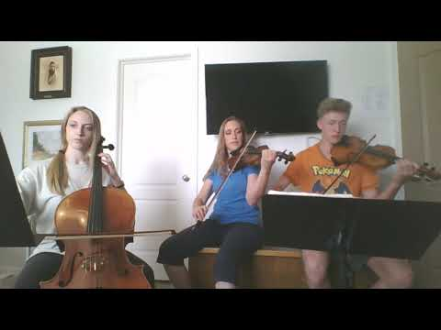(Dragonhunter on my website with me and my kids playing) and play along. Listen with headphones as you play THEN…
- Record yourself as you play along. Record on a different device as you will need one to listen. Wear the headphone so we can only hear you.
- Then I will put the recordings together and make a virtual concert with all of you on it. Won’t that be fun?!!

